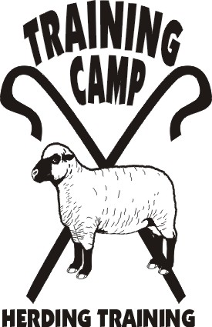

HERDING RULES

Now that you are getting ready to trial your dog, do you want to know and understand what the trial courses are?

Come to this seminar and learn the language, the similarities and differences between the trial courses available to you.

We will review and compare the AKC, ASCA, AHBA and USBCHA rules. There will be plenty of time for discussion and questions

April 29, 2007

10 am to 2 pm
$50

Limit 10 people. Lunch and seminar materials provided. This is for people, we will not be working dogs at this seminar.

Reservations must be made by April 10.

